**Documentation for Allied Books**

**Member:**

Kevin Burnside

Sangbeom Yi

**Source Code Management:**

Github: github.com/SeanSBYi/COMP229-TeamProject-MyBookStore-Fall2016

**Special Feature:**

WishList

**Site Diagram(by Visio):**

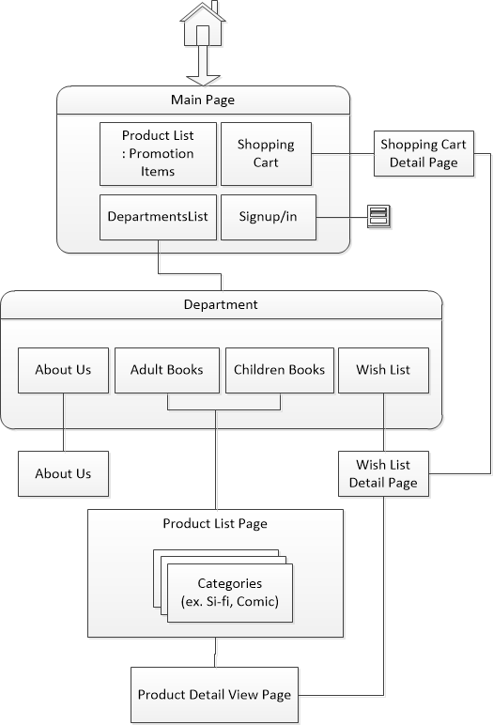

**Screenshot:**

Main Page



Product Page

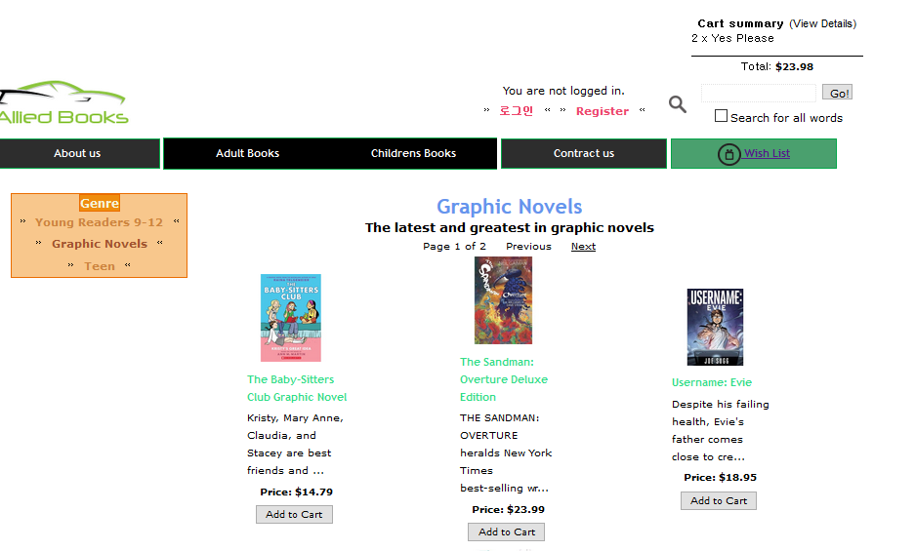

Shopping Cart

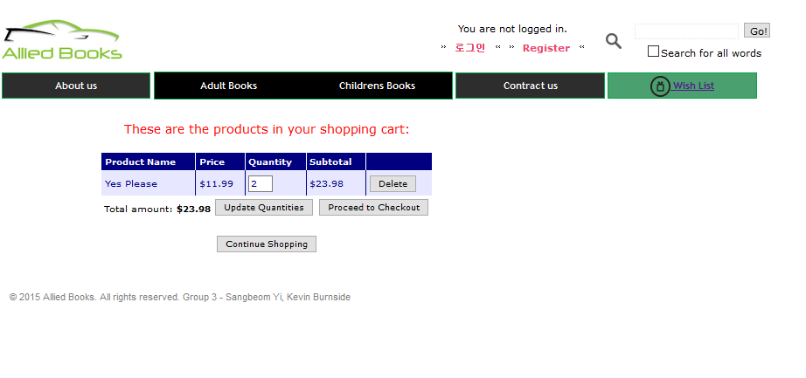

WishLis Page

